|  |  |
| --- | --- |
| *Module* | **Open to Buy** |
| *to* | B.TECH |
| *by* | ReBO Solutions |

Functional Documentation



Table of contents

**1. Introduction**4

1.1 Assumptions 4

1.2 Source Data 4

**2. OTB Functionalities**5-9

2.1. Login Screen 5

2.2. Main Menu 6

2.3. OTB – First Level Filtering 6

2.4. Second Level Filtering 7

2.5. Third level Filtering 7

2.6. Search Result Screen 8

2.7. Forecast overview 9-10

2.8. Input fields in the grid 11

2.9. OTB List and Details 12

**3. BMAPS OTB Approval Table** 12-13

3.1. OTB Access Control 12-13

|  |  |  |
| --- | --- | --- |
| **Authors** | | |
| **Name** | **Role** | **Department** |
| Madhu Ravindran | Technical Architect | REBO – IT |
| Elvis | Functional Architect | REBO – IT |

|  |  |  |  |
| --- | --- | --- | --- |
| **Document History** | | | |
| **Date** | **Version** | **Document Revision Description** | **Document Author** |
| 19th April 23 | V1 | OTB Functional Specification document | Rama Varakantham |
|  |  |  |  |
|  |  |  |  |
|  |  |  |  |
|  |  |  |  |

|  |  |  |  |
| --- | --- | --- | --- |
| **Approvals** | | | |
| **Approval Date** | **Approved Version** | **Approver Role** | **Approver** |
|  |  |  |  |
|  |  |  |  |
|  |  |  |  |
|  |  |  |  |

Document history and approvals

# **Introduction**

Introduction

The OTB (Open to Buy) module process the number of products to Buy in this plan season based on the historic sales and based on multiple performance KPI’s of the products. Process of purchasing budget for future inventory orders for a specific period. It helps BTECH to stock the right amount of the right products for meeting the targeted budget.

The following criteria are considered for the module:

* The last version of the approved Budget allocated in the strategic plan.
* The period or season selection
* The hierarchy selection of channels, Family etc.,

## Assumptions

* The strategic plan has at least one approved budget for this user selection of categories

## Source Data

* Channel wise Sales file
* Channel wise Sales
* Channel wise Budget Report
* Channel wise Store Grading
* Channel wise Product / Item Master
* Store Master
* Supplier Master
* Size Master
* Sortimeter

functionalities

# **OTB Functionalities**

## Login Screen

|  |  |
| --- | --- |
| Fields | Functionality |
| Username | Use Active directory username for authentication |
| Password | Use Active Directory password |
| Sign in Button | Once signed in user will be able to access respective modules to which they have permission on |

functionalities

functionalities

## Main Menu

|  |  |
| --- | --- |
| Fields | Functionality |
| Main Menu Items | Once Logged in user will be able to access respective modules on which they have permission on |

## OTB – First Level Filtering

functionalities

|  |  |
| --- | --- |
| Fields | Functionality |
| Sales Channel | Multi Dropdown with search filed – Online, Retail, BtechX, Tech Hub, B2B |
| Product Family | Multi Dropdown with search field - AC, Mobile, TV, etc. |
| Product Sub Family | Multi Dropdown with search field |
| Brand / Supplier | Multi Dropdown with search field |
| Category | Multi Dropdown with search field |
| Subcategory | Multi Dropdown with search field |
| Store Region | Multi Dropdown with search field |
| Store Grading | High Premium, High Medium, Low – Premium |
| Store List | Store Code with Location |
| Item Code | Multi Dropdown with search field - SKU |
| Top Items | Top 50, 100 Items |
| Class | Multi Dropdown with search field – A, B, C |
| Submit Button | Click on submit button to execute search as per the option selected |

functionalities

## Second Level Filtering

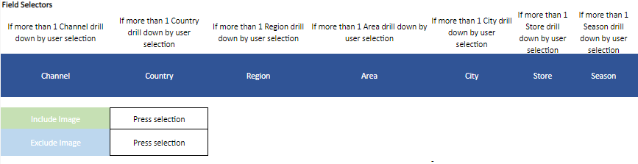

## Third Level Filtering

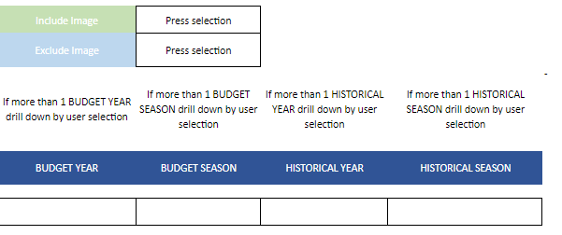

functionalities

functionalities

## Search Result Screen

functionalities

* After the filter, the OTB data will be displayed in Graph and Grid format.
* The value on the grid has to be segregated at price (gross & net), cost, quantity, margin and markdown which can be toggled through a tab method.
* The hierarchy should be year, month, week, day and SKU.
* The SKU data should be available at a higher level also based on the option selected on the top.
* All input cells should be highlighted in yellow.
* If the data changes, then the data in the cell will be highlighted with Orange color

| Fields | Functionality |
| --- | --- |
| OTB Process | Open to Buy Quantity is decided |
| Field Selector | Select required fields, fields are listed bellow |
| Sortimeter | Display Sortimeter data |

**

Historical Overview

Forecast Overview

functionalities

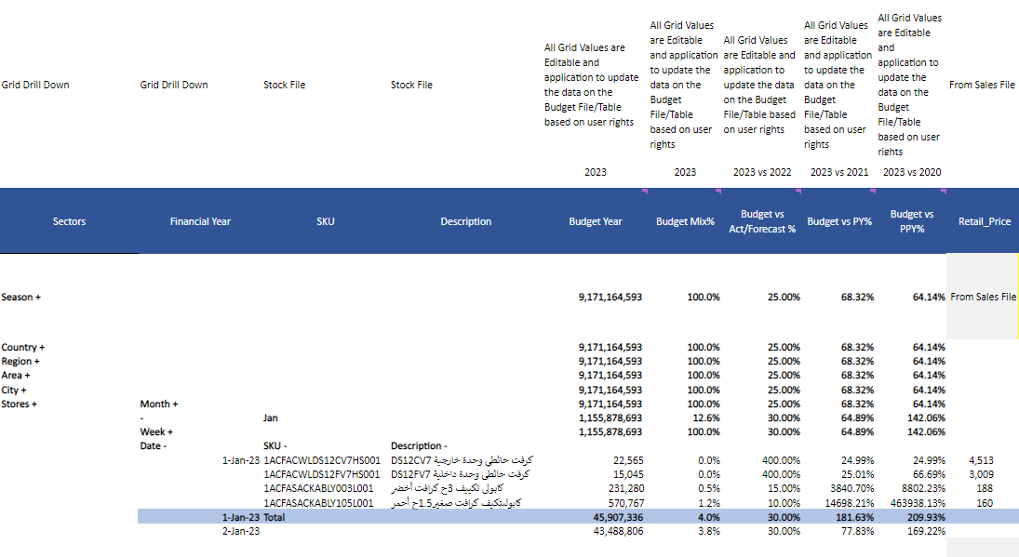

functionalities

functionalities



input fields

## Input fields in the grid

The value or % change at any level will be rolled over to the lower level of SKU and higher level of the period selection (day till year)

|  |  |  |  |
| --- | --- | --- | --- |
| Column Name | Description | Impacted Fields | Comments |
| Logistics % | Logistics |  |  |
| Budget columns | All the Budget and Budget mix columns | Refer to the excel for the columns that have column reference of KPI fields in the calculation |  |
| Proposed Sell Thru % | The KPI values can be modified at the Grid level along with the initial filtering | Refer to the excel for the columns that have column reference of KPI fields in the calculation |  |

ACCESS CONTROL & approval list

## OTB List and Details

List shows each search criteria that has been conducted, once you click on the respective search bottom screen shows the search details. This is similar to ASR. The OTB can be saved after manipulations of data and they can be viewed further. There will be 3 versions of the data saved.

Copy option will be provided to work on the previous version of saved OTB articles and enhance further.

The saved data can be exported to excel and csv

functionalities

1. **BMAPS OTB Approval Table and module wise access control:**

ACCESS CONTROL & approval list

approval list

Following table shows OTB Approval Matrix prepared by ReBO team. This has to be verified and updated by B-TECH for a final configuration on application.



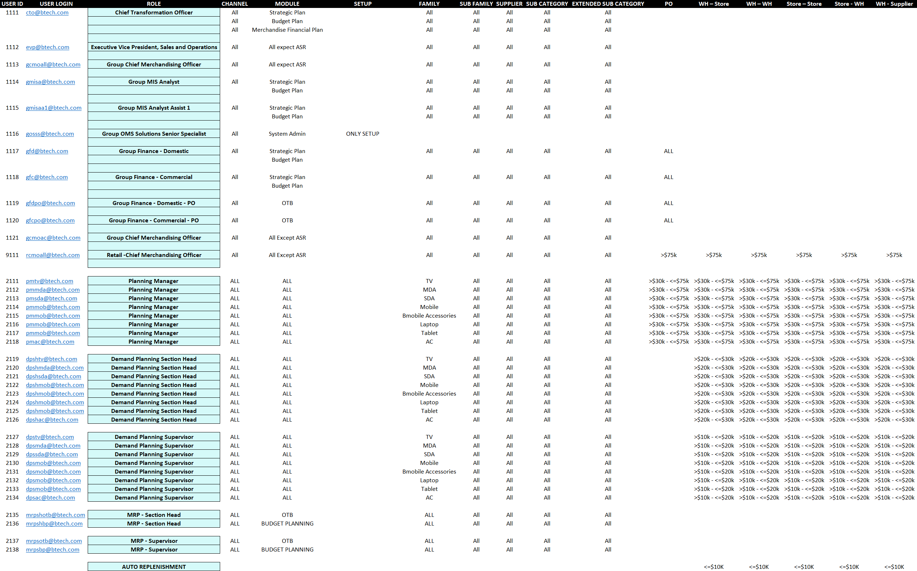

ACCESS CONTROL & approval list